**Trolling or Sexism with Bollywood celebrities?**

Trolling has been continuously carried out over Bollywood or Hollywood stars via various memes and video clips and even private comments. What is trolling about these days? Who are the main targets? What means are used to spread negative trolls for various celebrities? Who are these trolling people? Hold your breath as here we are going to uncover many cheap threats and trolls that Bollywood celebs have received!

While trolling generally targets all the actors and actresses, making fun of their clothing, pictures, shoots, and whatnot, many stars have faced a lot of naïve comments for them. Salman Khan was the center of these trolls a few years back due to his accident cases, Alia Bhatt too was targeted because of her poor general knowledge. A few months back, Sonakshi Sinha was forced to take off her social media handling because of the negativity spread across her account with the cheap comments. First, she was trolled because of her weight, and then she was targeted because of a Ramayana question to which she went blank. Tapsee Pannu, Priyanka Chopra, and others have also faced comments due to their short dresses or bikini shots.

There have been various memes and clips making fun of the Bollywood actors and actresses. But these trolls are seen to have taken a wide and a wrong turn, collaborating with sexism. These days, actresses are targeted more with body shaming, comments on modern clothing and even the worse are rape and death threats. Prostitutes, bitches, dumbest, and much more! Every cheap comment has been there for these actresses. They were even asked to die or leave the country. But, the transformation is now a lot brutal.

Kavita Krishnan, a women’s rights activist told Quartz that these trolls are sexist and gender-specific. Actors also face them, but Actresses are more targeted with evil ones.

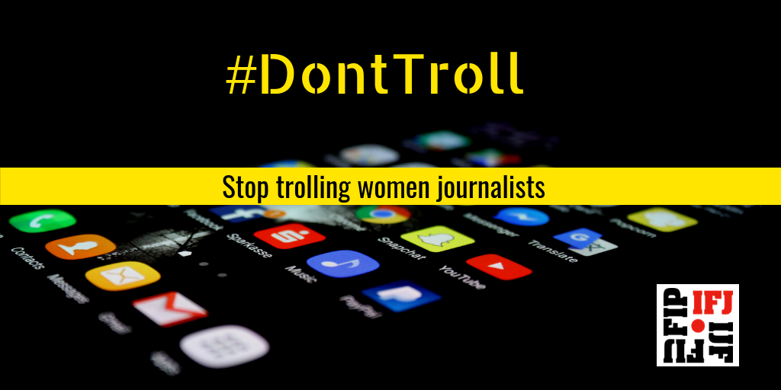

The trolling media took a cheap step with the fans of Jr NTR trolled actress Meera Chopra for her statement of liking Mahesh Babu and not Jr NTR. It was about the beginning of June when she received various obscene and cruel comments, even mentioning rape threats on her Twitter account. There were eight such to commit this by fake account creations that were soon deleted after the comment posting. FIR was registered for the same and twitter was asked to take down the comments.

Sushant Singh Rajput’s sad demise took a targeting turn for various actresses. How correct it is to give someone threats because of anyone else’s death? Just because your favorite super-star is dead, is it justified to target the females related directly or indirectly with the person and give them rape or death threats? Yes, this is what the most evil-eyed thing going on with various actresses after Sushant’s case.

* The targeting started with Kriti Sanon and Nupur Sanon when Sushant’s fans started pointing them out as fake people to which Nupur replied to seek permission from these people for some peace and condolences time. Alia Bhatt and Karan Johar too were trolled with the fact of being fake ones as once in ‘Koffee with Karan’ show, they were seen making fun of the late actor.
* However, not just being called fakes, these trolls turned out monstrous when Sonam Kapoor Ahuja’s unborn child was cursed by many people and she was cursed to cry for her child’s death too. She was also abused by many people and was given many death threats. This forced Sonam to shut off her and her parents’ comment section to avoid such obscenity. Sonam even posted a comment on how someone’s relatives or known cannot be blamed for anyone’s suicide unless the verdicts are proved.
* Not only this, but the rumored girlfriend of Sushant, Rhea Chakraborty was slut-shamed, called a gold digger, and also pointed out to be a murderer. But this didn’t stop here; a woman gave her rape and death threats, she asked her to suicide or else will be killed sooner or later. Being a woman, how is this even casual to give rape threats to any other woman?
* Moving on to Dil Bechara’s co-actress, Swastika Mukherjee was given rape and acid attack threats by a Hoogly resident Koushik Das who was soon arrested for the same. Not only him, but others were also arrested for such evil threats.

Not only the female actresses, but the female comedians are not spared too. Recent news came by when a 26-year old Gujarat’s boy, Sushant Mishra abused and gave various rape threats to Agrima Joshua and her mother and sister too. Ironically, the boy said that he respected women and then continued this nuisance.



These people have just been sexist, there is no such thing about trolling because it is now like a threat mainly for women to be scared. But, is it Justified?